NAM #MFGDay17 Social Media Kit
Manufacturing Day was designed to educate the public about manufacturing careers and manufacturing’s value to the economy through sponsored events, student outreach and general education.
As part of these community-driven efforts, we ask that you amplify the national event on social media, as stakeholders, partners and advocates, to help drive awareness. Help us spread the word of why manufacturing makes America strong on (and before!) October 6, 2017. Learn more at www.MFGDay.com.
We were able to make Manufacturing Day trend nationally on Twitter last year — together, we can do it again!
WHO TO FOLLOW ON TWITTER: @ShopFloorNAM, @MFGDay, @JayTimmonsNAM
WHO TO FOLLOW ON FACEBOOK: NAM, Jay Timmons, Friends of Manufacturing
HASHTAGS: #MFGDay17 #WeAreMFG
Example Tweets Pre-Event:
Manufacturers will be opening their doors for #MFGDay17. Find an event near you: MFGDay.com/Events pic.twitter.com/ahQVx24bpU
We celebrate #MFGDay17 to inspire the future to fill the jobs our industry will create. MFGDay.com/Events pic.twitter.com/JRe1HMfwRF

We celebrate #MFGDay17 to change perceptions about an industry that creates $2T a year. MFGDay.com pic.twitter.com/VtsVj0HtNK
We celebrate #MFGDay17 to encourage people to join one-tenth of the economy. MFGDay.com pic.twitter.com/hIiwsvJlu2

We celebrate #MFGDay17 to change perceptions of modern manufacturing. Find an event: MFGDay.com pic.twitter.com/daFXG8RBsp

When celebrating #MFGDay17, remember: manufacturers are hurt by the tax code. #TaxReform NAM.org/TaxReform pic.twitter.com/MEVMKbLzEK

#MFGDay17 is a celebration of manufacturing. It’s also a reminder that we need #TaxReform. NAM.org/TaxReform pic.twitter.com/2RHYQaEWqN

Example Facebook and LinkedIn Posts Pre-Event:
Manufacturing Day celebrates how manufacturers are making America. Help inspire the next generation of creators to pursue a career in modern manufacturing. Find an event near you at MFGDay.com
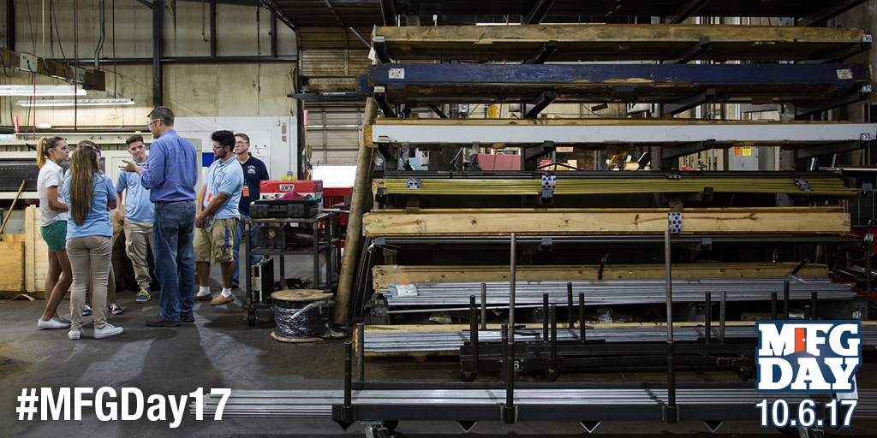
Why do we celebrate Manufacturing Day? To inspire the next generation to fill the 3.5M jobs our industry will create. Find an event near you at MFGDay.com/Events.
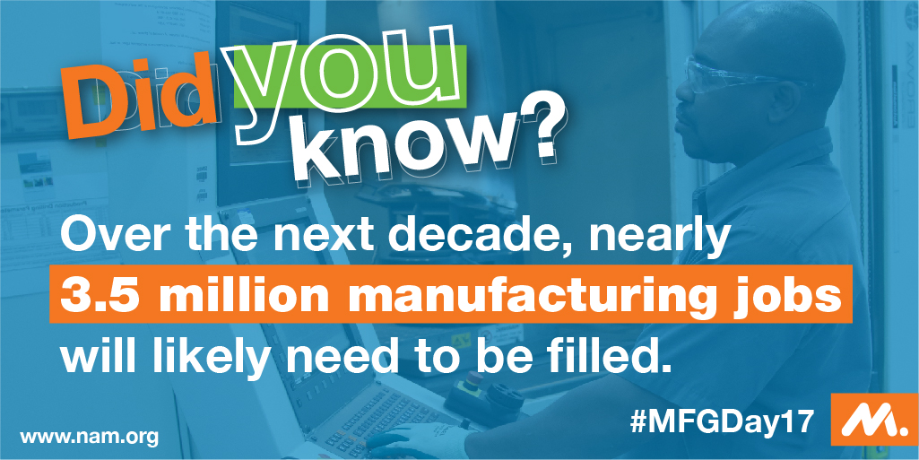

When celebrating Manufacturing Day, remember: manufacturers are hurt by the tax code. It’s time for tax reform. Lend your voice at NAM.org/TaxReform.

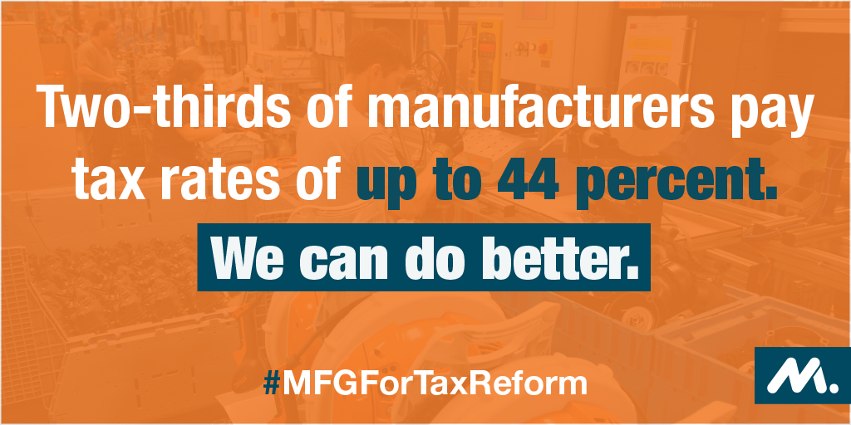

Manufacturers across the country celebrate Manufacturing Day to change the perception of modern manufacturing. Sign up for an event today at MFGDay.com.
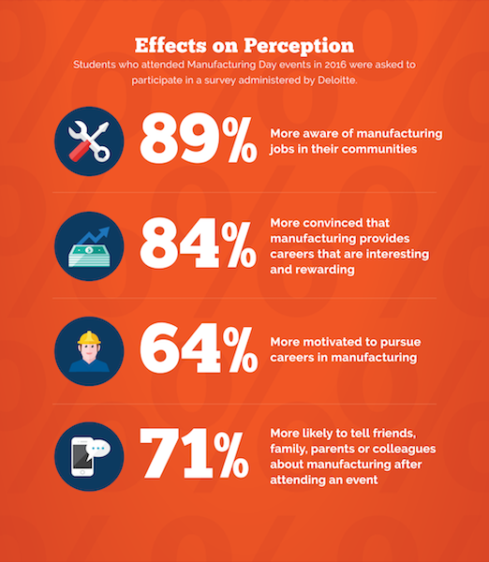

Before and during Manufacturing Day, feel free to tweet out and post your own photos with the #MFGDay17 hashtag, and retweet/share any posts from the NAM’s social accounts!

